**EXPERIMENT 4**

Write the python program for Cript-Arithmetic problem

**AIM:**

The aim is to solve the cript arithmetic problem using python program.

**PROGRAM:**

def is_valid_assignment(assignment, letters):

values = list(assignment.values())

return len(values) == len(set(values))

def evaluate_expression(expression, assignment):

value = 0

for char in expression:

value = value * 10 + assignment[char]

return value

def solve_cryptarithmetic(equation):

words = equation.replace("+", " ").replace("=", " ").split()

unique_letters = set("".join(words))

leading_letters = set(word[0] for word in words)

letters = list(unique_letters)

from itertools import permutations

for perm in permutations(range(10), len(letters)):

assignment = dict(zip(letters, perm))

if all(assignment[letter] != 0 for letter in leading_letters):

left_value = evaluate_expression(words[0], assignment)

right_value = evaluate_expression(words[1], assignment)

result_value = evaluate_expression(words[2], assignment)

if left_value + right_value == result_value:

return assignment

return None

equation = "SEND + MORE = MONEY"

solution = solve_cryptarithmetic(equation)

if solution:

print("Solution found:")

for letter, digit in solution.items():

print(f"{letter}: {digit}")

else:

print("No solution found.")

**INPUT:**

Send

More

-------------

**OUTPUT:**

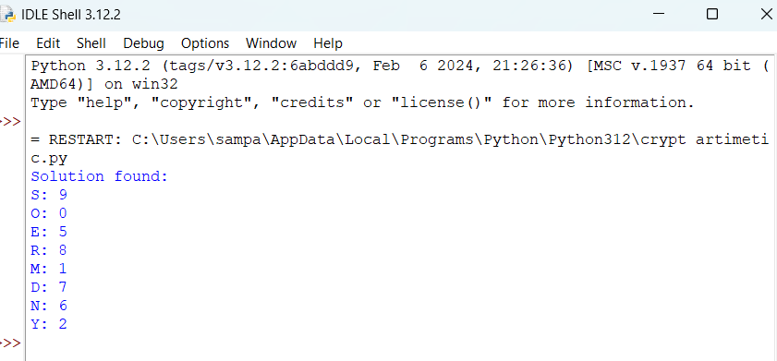

ggg